

CAPSTONE PROJECT REPORT

**Report 1 – Project Introduction**

– Da Nang, July 2022 –

Table of Contents

I. RECORD OF CHANGES 3

II. PROJECT INTRODUCTION 4

1. Overview 4

1.1 Project Information 4

1.2 Project Team 4

2. Product Background 4

3. Existing Systems 6

3.1 LinkedIn 6

3.2 Careerbuilder 7

3.3. Vietnamworks 8

3.4. Indeed.com 9

4. Business Opportunity 10

5. Software Product Vision 10

6. Project Scope & Limitations 10

6.1 Major Features 11

6.1.1 Administration Site 11

6.1.2 Recruit Site ……………………………………………………………….11

6.1.3 Guest Site ……………………………………………………………….11

6.1.4 Job seeker Site 11

6.2 Limitations & Exclusions 12

# RECORD OF CHANGES

|  |  |  |  |
| --- | --- | --- | --- |
| **Date** | **A\***  **M, D** | **In charge** | **Change Description** |
|  |  |  |  |
|  |  |  |  |
|  |  |  |  |
|  |  |  |  |
|  |  |  |  |
|  |  |  |  |
|  |  |  |  |
|  |  |  |  |
|  |  |  |  |
|  |  |  |  |
|  |  |  |  |
|  |  |  |  |
|  |  |  |  |

*A - Added M - Modified D - Deleted

# PROJECT INTRODUCTION

# Overview

# Project Information

* + - * Project name: Finding Jobs System
      * Project code: FJS
      * Group name: SWP490 – G10
      * Software type: Web application
      * Project Goal: The website system that I am building is like a link between employers and job seekers. Make it easy for job seekers to find the right job for them and help recruiters find the right candidate for the position they need to fill. The site also has a number of helpful articles and tips for users.

# Project Team

|  |  |  |  |
| --- | --- | --- | --- |
| **Full Name** | **Role** | **Email** | **Mobile** |
| Nguyen Tien Dat | Leader | [datntde140180@fpt.edu.vn](mailto:datntde140180@fpt.edu.vn) | 0836369457 |
| Nguyen Hoang Anh Tuan | Member | tuannha[de140212@fpt.edu.vn](mailto:de140212@fpt.edu.vn) | 0377927778 |
| Vo Nguyen Son Tra | Member | [travnsde140205@fpt.edu.vn](mailto:travnsde140205@fpt.edu.vn) | 0985317024 |
| Nguyen Dac Phi Truong | Member | [truongndpde140082@fpt.edu.vn](mailto:truongndpde140082@fpt.edu.vn) | 01226949667 |
| Tran Viet Hoang | Member | [hoangtvde140186@fpt.edu.vn](mailto:hoangtvde140186@fpt.edu.vn) | 0913889392 |

# Product Background

Before the great development of the economy, many professions became scarce or lacked good human resources. In Vietnam, many businesses have a need to recruit employees for the company with many salaries from low to high depending on capacity. Along with that, after the pandemic ends, many people have the need to find jobs in the right major with a suitable salary. At the Job Search System, you can view the top job postings with extremely attractive salaries. Recruitment agencies are leading companies in Vietnam. You will have the opportunity to work in domestic companies and foreign-invested enterprises. Therefore, the need to find jobs online in our society is increasing day by day.

With the effective help of technology, there are many job search websites born to meet the requirements of users, such as:

Find work faster and easier. Use the service for free.

After surveying, we realized that searching for jobs on these online job search sites is also easy to waste a lot of time in vain. The reason comes from the very benefit of this form of job search, which is that there are too many jobs shown here. At that time, we easily fall into the situation of looking at one thing after another without being able to make a final decision because we feel that the latter job has better regimes than the previous one.

For these reasons, our team decided to create a system that includes the capabilities of a website as well . With many job options, this system can personalize job recommendations, identify suitable candidates for that job, and especially our system will have good newsletters to help support candidates and recruiters find the right puzzle piece. When users use our app, we want them to have the best experience possible.



***Figure 1: Job search overview***

# Existing Systems

# LinkedIn

LinkedIn is an American business and employment-oriented online service that operates via websites and mobile apps. Launched on May 5, 2003, the platform is primarily used for professional networking and career development, and allows job seekers to post their CVs and employers to post jobs. This website is designed in a straightforward manner, with a white backdrop and two primary text colors, black and blue. The site's primary language is English.

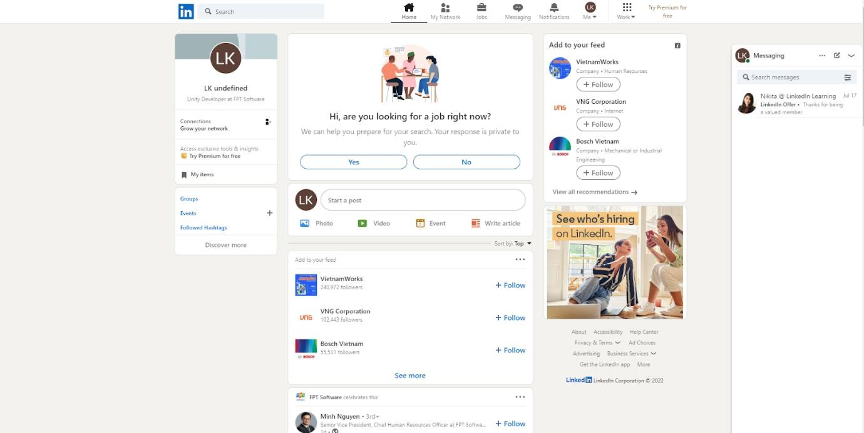

## Figure 2: Linkedin Website

Link: <https://www.linkedin.com/>

* Advantages:
  + Linked In has 810 million users in more than 200 countries and territories worldwide.
  + Nike Interface, easy to search and apply jobs.
  + Notifications real time in app and mail.
* Disadvantage:
  + Will make spam.
  + Premium is expensive (600$ 1 years).

# Careerbuilder

CareerBuilder is one of the largest job boards, providing job listings, resume posting, career advice, and resources for job seekers. CareerBuilder protects job listings directly from employers and has expanded local listings by partnering with multiple newspapers to incorporate their online classifieds sites. GiveTake a look at me the "Career Handbook" section, which teaches a lot of job management and handling skills that not everyone knows. This manual can be of great help to us. Even if you can't find a job, you should read the skills guide here, it's not a waste.

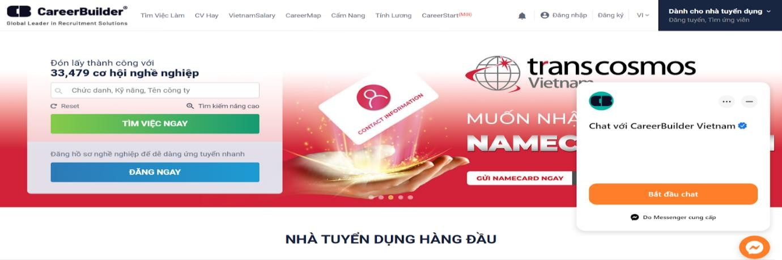

## Figure 3: Careerbuilder Website

Link: <https://careerbuilder.vn/>

* Favorable:
  + The number of daily page visits is up to thousands of times.
  + Beautiful interface, easy to use and very good customer support.
  + has a simple but pretty neat and smart website design.
* Disadvantage:
  + Will make spam.

### 3.3. Vietnamworks

Vietnamworks is one of the first following working websites in Vietnam. Here you can find thousands of jobs registered every day in a variety of locations and fields. Registered users can upload CVs, resumes, get salary information, store resumes and more. cover letter, and job tracking. You'll also find career advice and tech news for job seekers.

Instead of using a site search engine, users simply type a job into their Google search bar. Google will then list the job related. Users can then collect their earnings by job type, location, company type, posting date, etc.

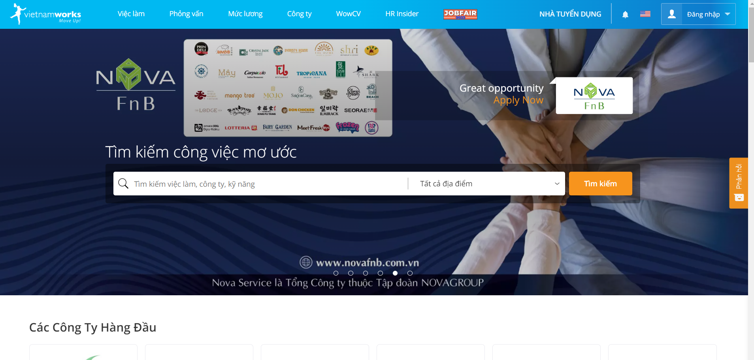

## Figure 4: Vietnamworks Website

Link*:* [*Vietnamworks.com*](https://www.vietnamworks.com/)

❖ Advantages:

● Many user support functions

● Nice interface, easy to use and very good customer support.

● Support login in many forms such as facebook, gmail.

❖ Disadvantage:

● Having too many choices will confuse you.

### 3.4. [Indeed.com](https://vn.indeed.com/?r=us)

Truly a top job site with millions of job listings from the thousands of pages web, including company career sites, job boards, newspaper classifieds, associations and other subscription sources online. Users can also upload their CV, resume and get a personalized link to the resume to share with employers. You can also apply at Indeed.com, monitor and trend jobs, set up job alerts, and use the job search app for quick mobile job searches.

If you want to avoid spam, scams, and duplicate job listings, then this is the job site for you. Here, only post jobs offered on company websites, providing candidates with jobs that are not typically featured. Because the jobs come directly from the company's website, you can be sure that they are open.

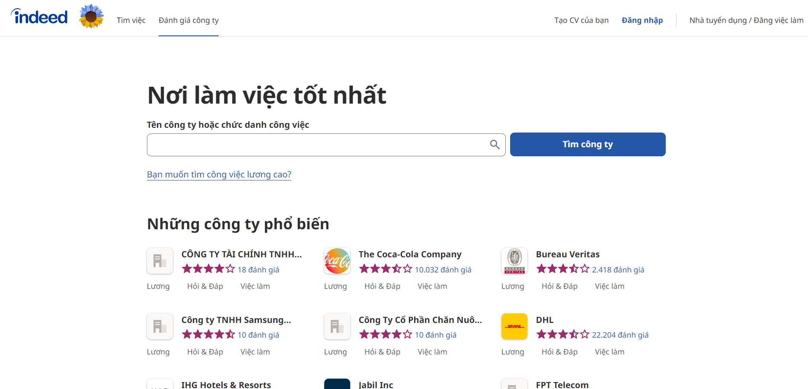

## Figure 4: Indeed Website

Link*:* [*Indeed.com*](https://www.vietnamworks.com/)

❖ Advantages:

• Having too many choices will confuse you.

• Easy-to-use interface, easy job search.

• Real-time notifications in apps and mail.

❖ Disadvantage:

• There are many costs incurred.

• Expensive insurance premiums.

# Business Opportunity

Today, the trend of customers using the internet, especially social networks, is increasing. This can make it easier for customers to find out about our website, which in turn can improve our image and brand awareness.

Imagine, now you are looking for a job but you know what you want to do? Where do you want to work?

Our website will help recruiters and candidates find each other. Now you can find thousands of jobs online that match your needs. Employers will also find the right candidate for their job. Such a Web site will save everyone a lot of time and effort.

# Software Product Vision

Our job search system is an Internet-based and smartphone-enabled application. In addition, the system will help candidates save for their favorite jobs. Candidates can also view daily counseling information to know more potential job knowledge. Besides, the system helps recruiters to post advertisements about their company.

These help candidates and employers connect with each other comfortably right on their own phones or computers and only need an internet connection. Will save people time and will increase the choices available to them.

# Project Scope & Limitations

The find job system was deployed by us for a period of 4 months from May 2022 to the end of August 2022. The purpose of the project is to create a find job platform for people in the information technology industry. To be specific, people can access our system via website or phone to find a job, then they can view recruitment posts, companies, and detailed job descriptions. If users are logged in to their account, they can submit their CV online directly through the website through the article they have viewed before easily.

# Major Features

* + 1. Administration Site
       - FE-01: Employer management: view profiles, search, add, update and delete.
       - FE-02: User management: view profiles, search, add, update and delete.
       - FE-03: Manage job postings: view, search, add, update, moderate and delete.
       - FE-04: Admin management: search, add, update and delete.
       - FE-05: More staff, Decentralization
    2. Recruit Site
       - FE-01: Manage account.
       - FE-02: Manage recruitment posts: view, search, add, update and delete.
       - FE-03: Manage candidate applied: view candidate's cv, contact candidate via the phone number or email on cv.
    3. Guest Site
       - FE-01: Register or login.
       - FE-02: View, search recruitment posts.
    4. Job seeker Site
       - FE-01: Manage account.
       - FE-02: Search, view recruitment posts.
       - FE-03: Candidates can apply their cv next to the recruitment post.

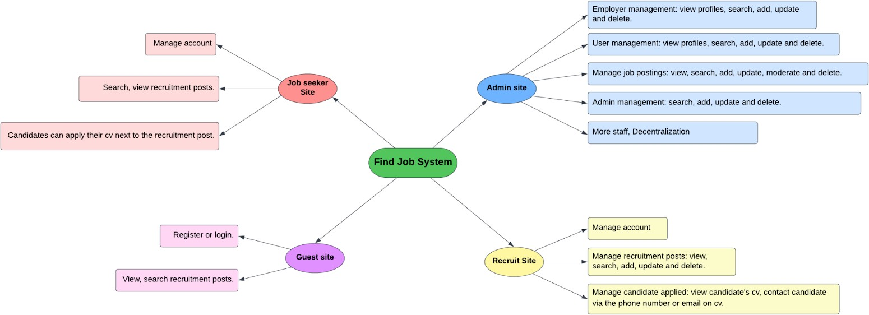

***Figure 5: Major Feature Map***

# Limitations & Exclusions

LI-1: Admin can delete a post if it is inappropriate.

LI-2: Recruitment can't post without admin's permission.

LI-3: Job seekers cannot submit CVs without updating their CVs.